Clam Dissection
Introduction
The phylum Mollusca includes snails, clams, chitons, slugs, limpets, octopi, and squid. As mollusks develop from a fertilized egg to an adult, most pass through a larval stage called the trocophore. The trocophore is a ciliated, free-swimming stage. Mollusks also have a radula or file-like organ for feeding, a mantle that may secrete a shell, and a muscular foot for locomotion. Clams are marine mollusks with two valves or shells. Like all mollusks, a clam has a mantle which surrounds its soft body. It also has a muscular foot which enables the clam to burrow itself in mud or sand. The soft tissue above the foot is called the visceral mass and contains the clam's body organs.
Objective
To study the internal and external anatomy of a bivalve mollusk.
Materials
Dissecting pan, dissecting kit, lab apron, plastic gloves, preserved clam
Procedure
- Put on your lab apron, safety glasses, and plastic gloves.
- Place a clam in a dissecting tray and identify the anterior and posterior ends of the clam as well as the dorsal, ventral, & lateral surfaces. Figure 1
Figure 1
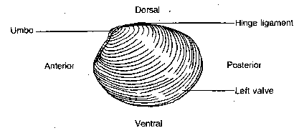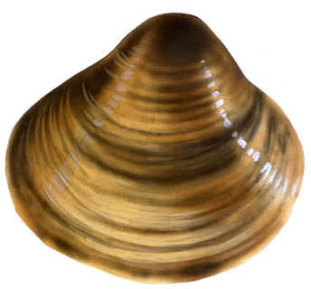

- Locate the umbo, the bump at the anterior end of the valve. This is the oldest part of the clam shell. Find the hinge ligament which hinges the valves together and observe the growth rings.
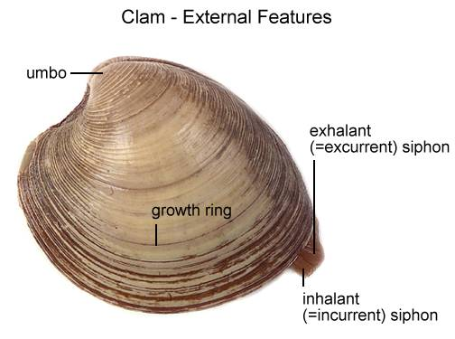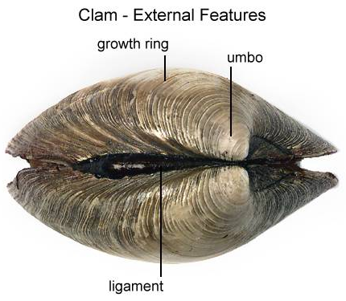
- Turn the calm with its dorsal side down and insert a probe between the ventral edges of the valves. Carefully work the tip of the probe between the valves so you do not jab your hand.
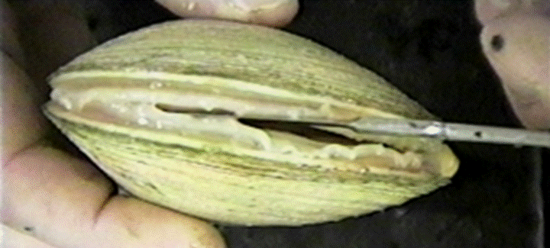
- Turn the probe so that the valves are about a centimeter apart. Leave the tip of the probe between the valves and place the clam in the pan with the left valve up.
- Locate the adductor muscles. With your blade pointing toward the dorsal edge, slide your scalpel between the upper valve & the top tissue layer. Cut down through the anterior adductor muscle, cutting as close to the shell as possible.
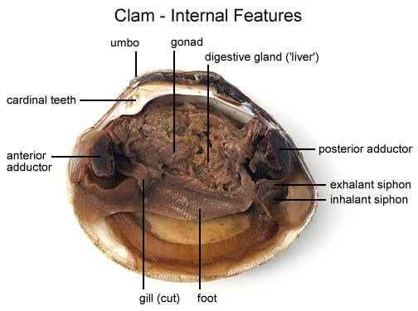
- Repeat step 6 in cutting the posterior adductor muscle. Figure 2
Figure 2
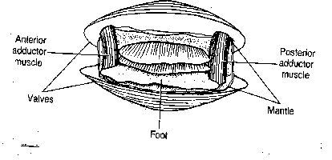
- Bend the left valve back so it lies flat in the tray.
- Run your fingers along the outside and the inside of the left valve and compare the texture of the two surfaces.
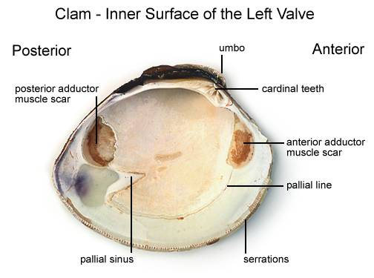
- Examine the inner dorsal edges of both valves near the umbo and locate the toothlike projections. Close the valves & notice how the toothlike projections interlock.
- Locate the muscle "scars" on the inner surface of the left valve. The adductor muscles were attached here to hold the clam closed.
- Identify the mantle, the tissue that lines both valves & covers the soft body of the clam. Find the mantle cavity, the space inside the mantle.
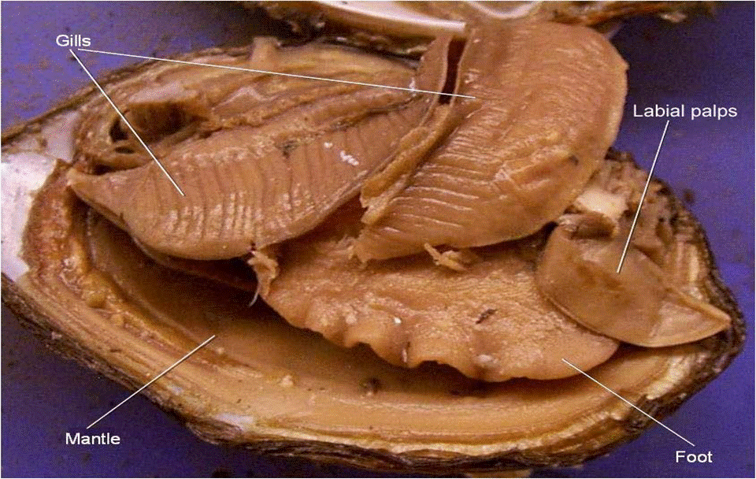
- Locate two openings on the posterior end of the clam. The more ventral opening is the incurrent siphon that carries water into the clam and the more dorsal opening is the excurrent siphon where wastes & water leave.
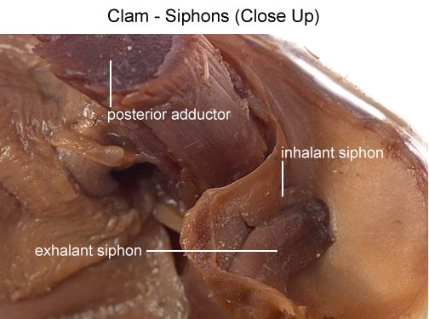
- With scissors, carefully cut away the half of the mantle that lined the left valve. After removing this part of the mantle, you can see the gills, respiratory structures.
- Observe the muscular foot of the clam, which is ventral to the gills. Note the hatchet shape of the foot used to burrow into mud or sand.
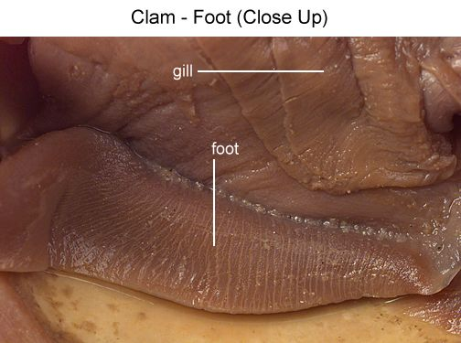
- Locate the palps, flaplike structures that surround & guide food into the clam's mouth. The palps are anterior to the gills & ventral to the anterior adductor muscle. Beneath the palps, find the mouth.
Figure 3
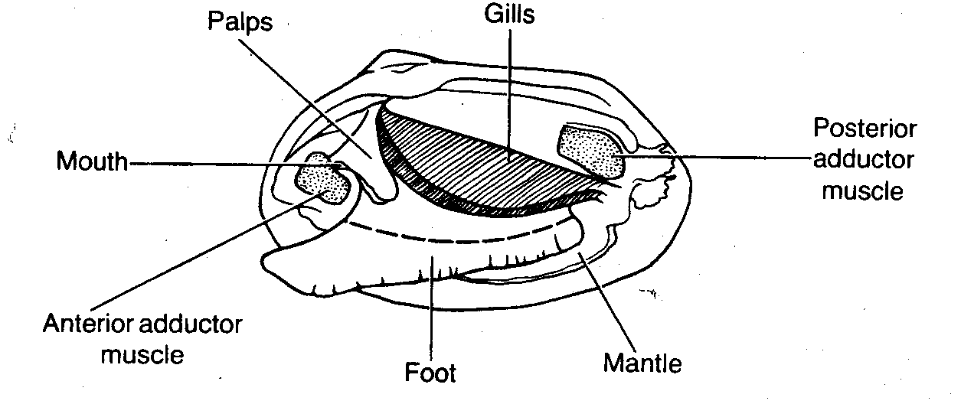
- With scissors, cut off the ventral portion of the foot. Use the scalpel to carefully cut the muscle at the top of the foot into right and left halves.
- Carefully peel away the muscle layer to view the internal organs.
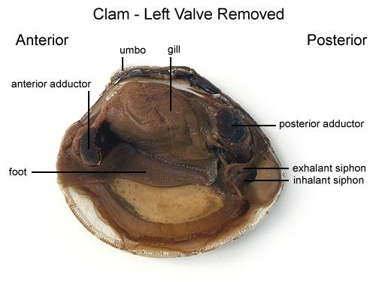
- Locate the spongy, yellowish reproductive organs.
- Ventral to the umbo, find the digestive gland, a greenish structure that surrounds the stomach.
- Locate the long, coiled intestine extending from the stomach.
- Follow the intestine through the calm. Find the area near the dorsal surface that the intestine passes through called the pericardial area. Find the clam's heart in this area.
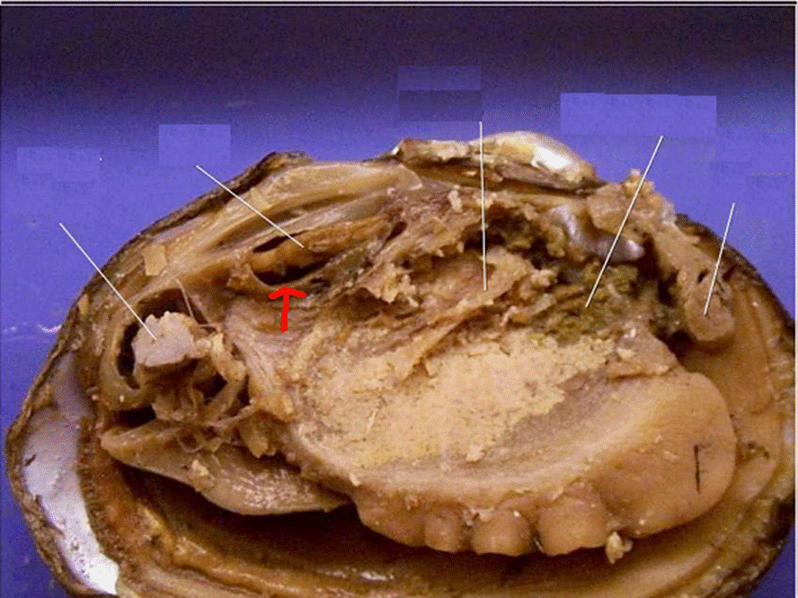
- Continue following the intestine toward the posterior end of the clam. Find the anus just behind the posterior adductor muscle.
- Use your probe to trace the path of food & wastes from the incurrent siphon through the clam to the excurrent siphon.
- Answer the questions on your lab report & label the diagrams of the internal structures of the clam. Also, use arrows on the clam diagram to trace the pathway of food as it travels to the clam's stomach. Continue the arrows showing wastes leaving through the anus.
When you have finished dissecting the clam, dispose of the clam as your teacher advises and clean, dry, and return all dissecting equipment to the lab cart. Wash your hands thoroughly with soap!
Clam Dissection Questions
Pre-lab:
1. Give the kingdom, phylum, and class for the clam.
2. Describe the body of bivalves.
3. How do bivalves move?
4. Why are they called bivalves?
5. Is their digestive tract complete or incomplete? Explain your answer.
6. Do bivalves show cephalization? Explain your answer.
7. What are siphons & what is their purpose?
8. How can you distinguish a mussel from a clam?
9. Adults are usually sessile, but the larva or _________________ is free-swimming.
10. Are bivalves protostomes or deuterostomes?
11. Their body cavity is called the _____________ cavity.
12. Body organs make up the ___________ mass and are protected by the _____________ which secretes the ___________.
13. Is circulation open or closed?
14. Give several examples of bivalves.
Lab Questions:
1. What is the oldest part of a clam's shell called and how can it be located?
2. What do the rings on the clam's shell indicate?
3. Name the clam's siphons.
4. What holds the two shells together?
5. What muscles open & close the clam?
6. Describe the inside lining of the shell.
7. What is the function of the tooth-like projections at the dorsal edge of the clam's valves?
8. Where is the mantle located in the clam? What is its function?
9. Describe the clam's foot.
10. What is the mantle cavity?
11. How do clams breathe?
12. What helps direct water over the gills?
13. Where are the palps found and what is their function?
14. Describe the movement of food from the current siphon through the digestive system of the clam.
15. Where is the clam's heart located?
16. What are the parts of the clam's nervous system?
17. Why are clam's referred to as "filter feeders"?
18. Label the internal structures of the clam and draw arrows showing the pathway of food as it travels to the clam's stomach:


